**Implement Frameworks the DevOps way By Simplilearn E-Commerce-Website-Sporty Shoes**

1. **Sporty Shoes:**

This document contains sections for: • Project Description • Core concepts used in project • Flow of the Application. • Project Users Stories: (Agile and Scrum) • Git Repositories • How to run project • Demonstrating the product capabilities, appearance, and user interactions. • Unique Selling Points of the Application • Conclusions

The code for this project is hosted at:

**The project is developed by:** Sunny Mishra

**1.1 Project Description:**

Project objective: As a Full Stack Developer, complete the features of the application by planning the development and pushing the source code to the GitHub repository.

Background of the problem statement: Sporty Shoes is a company that manufactures and sells sports shoes. They have a walk-in store, and now, they wish to launch their e-commerce portal sportyshoes.com.

You’re asked to develop a prototype of the application. It will be then presented to the relevant stakeholders for budget approval. Your manager has set up a meeting where you’re asked to do the following:

● Presenting the specification document which has the product’s capabilities, appearance, and user interactions

● Setting up Git and GitHub account to store and track your enhancements of the prototype

● Explaining the Java concepts used in the project

● Discussing the generic features of the product:

● There will be an admin to manage the website. An administrator login will be required to access the admin page.

The admin should be able to change his password if he wants, he should be able to: ● Manage the products in the store including categorizing them ● Browse the list of users who have signed up and be able to search users ● See purchase reports filtered by date and category

**1.2 Core concepts used in the project:**

-> Used Java Language in Eclipse IDE. -> File Handling -> Spring framework -> Flow Control -> Recursion -> Exception Handling -> Streams API TECHNOLOGIES AND TOOLS USED:

Spring MVC: to build web applications as it follows the Model-View-Controller design pattern.

• JSP: to handle the presentation view

• Hibernate: to simplify the development and the interaction with the database. • CSS: to format the contents.

• Bootstrap: to use some CSS and JavaScript designs.

• Maven: to manage the project.

• Eclipse: to write and run the code.

• phpMyAdmin: to administrate and manage the database manually.

• Tomcat: to run and deploy servlet application.

1. **Architecture diagram / flow chart**

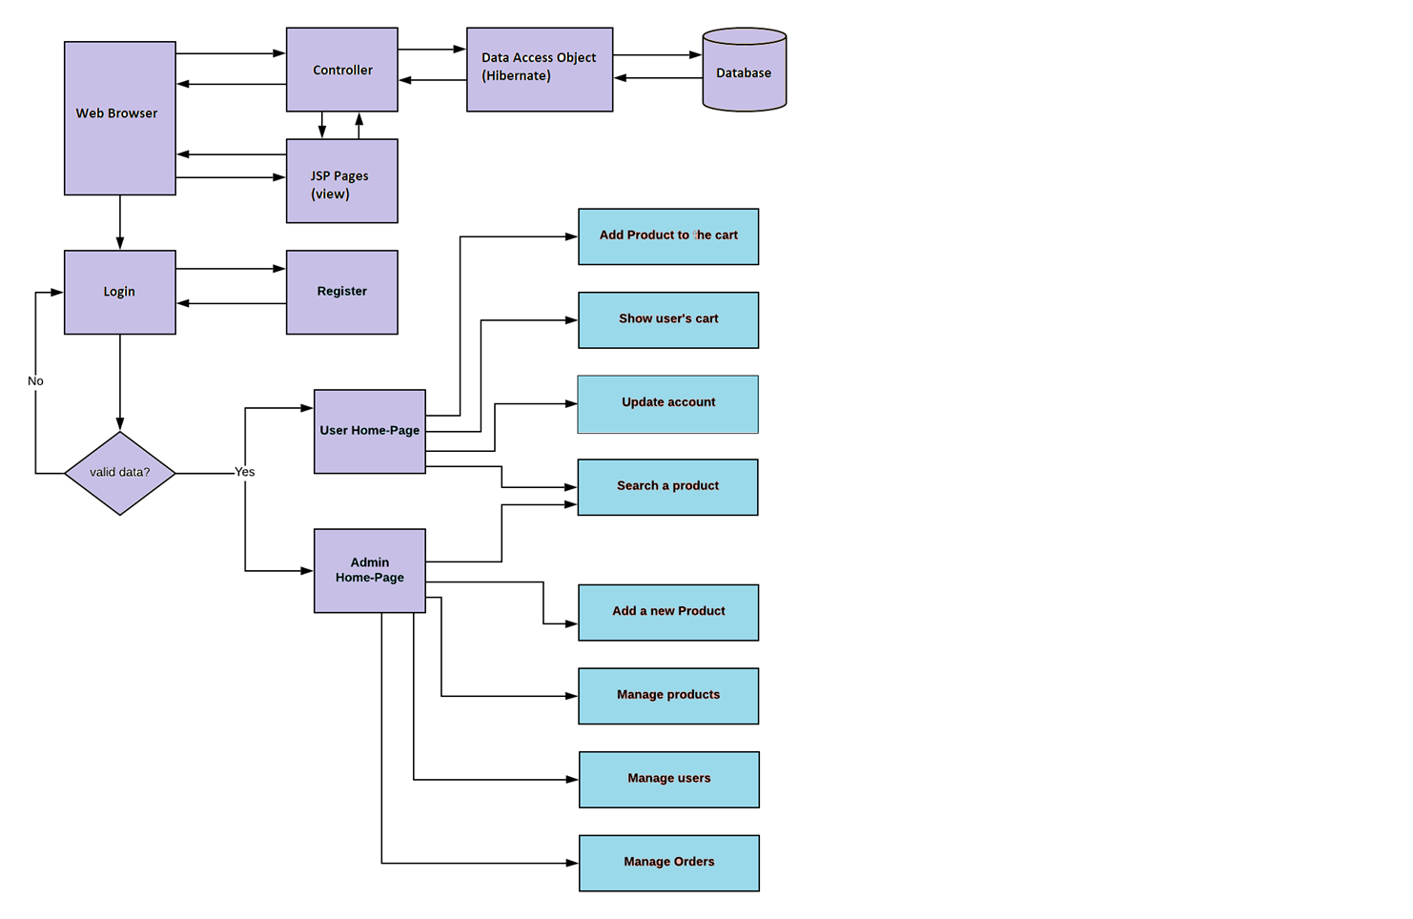

2.1 **Project Users Stories : ( Agile and Scrum )**

The project is planned to be completed in 3 sprints. Tasks assumed to be completed in the sprint are: • Creating the flow of the application • Initializing git repository to track changes as development progresses. • Writing the Java program to fulfill the requirements of the project. • Testing the Java program with different kinds of User input • Pushing code to GitHub.

1. As an admin I can Set up a product list of all the shoes.
2. As an admin I can Delete any shoe product.
3. As an admin I can Manage users.
4. As an admin I can change new password. 5)As a User, I can add product to the list. The goal of the company is to deliver a high-end quality product as early as possible.

**Sprint 1**

1. Create database and tables.
2. Add all dependencies to the Maven project. Connect the database to the project.
3. Create the models’ classes. Create the data access object classes using Hibernate. Sprint 2
4. Create login and register pages. Show all products to the home page.
5. Add products to the cart. Show user’s cart. Create user’s update page.
6. Enable the admin to add a new product. Enable the ability to search for a specific product. Sprint 3
7. Make the admin able to update and remove a product. Make the admin manage the users.
8. Make the admin manage the orders. Add CSS file and use Bootstrap to format the pages. Debug and test the project.
9. Push the code to the GitHub. The goal of the company is to deliver a high-end quality product as early as possible.

**3. Unique Selling Points of the Application**

1. Scheduled products for users can be maintained easily.
2. The data of the users and products can be edited easily.
3. High security for the data as the admin only can access the data.
4. Searching for any data about users is made easy Conclusions In the program an application has been developed with a duration of three spirits. This application makes handling the data of the Sporty Shoes. All the data about the Shoe products, user’s purchase details and their schedule are maintained. The admin can login through a User ID and password and manipulated the data.

**4. Screenshots**

